Name: | ___________________________________________________ |  |  |  | Date: ___________
 | Year 10 Mathematics  Investigation 2, 2015  Topic – Sketching Parabolas  Take-Home Section
Important Information:
Although the complete take-home component is not worth any marks, it is essential in preparation for the in-class validation component. Knowledge and skills gained will be extended in the validation component. This in-class validation will be completed under test conditions on the day in which this take-home component is due. The take home component may be used when completing the validation.

Date out: |  | Week ____ Date _________ | Date Due: | Week ____ Date _________
Take home component weighting: |  | 0% of the year | In-class component weighting: | 10 % of the year

In this investigation you will learn how to sketch parabolas whether they are in the general form, factorised from or completed square form and be able to identify and record key features of these graphs.

A simple quadratic function can be written in one of the following forms:

General Form y = x² + bx +c

Factorised Form y = (x – d)(x – e)

Completed Square Form y = ±(x – a)² + b

Where the letters a, b, c , d and e are numbers. These functions are called monic quadratics because the co-efficient of the x² is 1. The graphs of these functions are called parabolas.

Key Features
Whenever you draw a graph, you will be asked to identify key features of your graph and either list them or label them on your graph. Below is a list of the key features that you are often required to identify. Beside each feature write its definition.

Key Feature | Definition
y-intercept

x-intercept

Axis of symmetry

Turning point

Graphing a Parabola from a Factorised Quadratic.
If the quadratic factorise then it is easier to sketch the graph than to sketch from the general form. Use the following steps to find the key features. Once you have the key features, you should be able to sketch the parabola.

- Find the y-intercept
The y-intercept occurs on a graph when the x co-ordinate is zero. The Cartesian co-ordinate of every y-intercept is (0, y), where y is a number. To find it from our equation we substitute x = 0 into our equation.

Example:
y = (x + 1)(x – 5)
substituting x = 0 y = (0 + 1)(0 – 5)
= 1 × -5
= -5

The y-intercept occurs on the y-axis at -15. Its co-ordinate is (0, -15)

Can you see a shortcut?

- Find the x-intercepts
There are usually two x-intercept and they occur on a graph when the y co-ordinate is zero. The Cartesian co-ordinate of every x-intercept is (x, 0), where x is a number. To find it from our equation we substitute y = 0 into our equation and solve.

Example:
y = (x + 1)(x – 5)
substituting y = 0 0 = (x + 1)(x – 5)

If either factor (x + 1) or (x – 5) are zero then the answer will be zero (This is called the null factor law). So there will be two possible answers.

If x = -1 then the first bracket will be zero

0 = (-1 + 1)(-1 – 5)
= 0 × -6
= 0
If x = 5 then the second bracket will be zero

0 = (5 + 1)(5 – 5)
= 6 × 0
= 0

Therefore the x-intercepts occur on the x-axis at -1 and 5. Their co-ordinates are (-1, 0) and (5, 0)

Can you see a shortcut?

- Find the axis of symmetry
Parabolas are symmetrical graphs that have an axis of symmetry running down the middle of the graph. This line is always halfway between the two x-intercepts. To easily find its location add the two x-ordinates from the x-intercepts together and then divide by 2.

Example:
y = (x + 1)(x – 5)

x-intercepts are (-1, 0) and (5, 0)

(-1 + 5) ÷ 2 = 2

The line of symmetry is written as x = 2 and is vertical dotted line through 2 on the x-axis

- Find the turning point
The turning point is always on the line of symmetry. To find its co-ordinate substitute the line of symmetry into the equation

Example:
y = (x + 1)(x – 5)
substituting x = 2 y = (2 + 1)(2 – 5)
= 3 × -3
= -9

So the turning point is at (2, -9)

Exercise 1
List the 4 key features of each of the following graphs
- y = (x + 2)(x + 4)

- y = (x + 4)(x - 2)

- y = (x - 2)(x - 6)

- y = (x - 1)(x + 2)

Sketching a parabola
- Mark with an × the 4 co-ordinates that you calculated from the key features
- Draw a dotted vertical line for the axis of symmetry
- Join the ×’s up with a smooth curve, no sharp edges and a curve at the turning point
- Put arrow heads on the ends of the parabola.

Example:
y = (x + 1)(x – 5)

y-intercept = (0, -5)
x-intercepts = (-1, 0) and (5, 0)
Axis of symmetry: x = 2
Turning Point = (2, -9)

Sketch the four graphs from exercise 1 on the grids below. List the key features in the boxes on the right.
a) | y = (x + 2)(x + 4)  y-intercept =  x-intercepts = and  Axis of symmetry:  Turning Point =
b) | y = (x + 4)(x - 2)
c) | y = (x - 2)(x - 6)
d) | y = (x - 1)(x + 2)

Graphing a Parabola from a Completed Square Quadratic.
If the quadratic is in the completed square form, we find the turning point first, draw the graph second, then read the x and y intercepts off the graph

- Finding the turning point
With a quadratic in the form of y = ±(x – a)² + b the turning point is located at (a, b)

Examples:
y = (x – 1)² – 2 Turning point at (1, -2)
y = (x – 5)² + 3 Turning point at (5, 3)
y = (x + 2)² – 7 Turning point at (-2, -7)
y = (x + 6)² + 5 Turning point at (-6, 5)

Notice the opposite signs with the first number but the same signs with the second number.

- The axis of symmetry
Since we know the turning point, we know the axis of symmetry: x = -a

Examples:
y = (x – 1)² – 2 Turning point at (1, -2) x = 1
y = (x – 5)² + 3 Turning point at (5, 3) x = 5
y = (x + 2)² – 7 Turning point at (-2, -7) x = -2
y = (x + 6)² + 5 Turning point at (-6, 5) x = -6

- Draw the graph
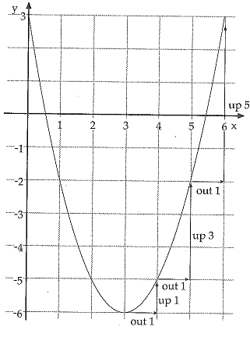
Starting at the turning point, we can draw the graph because there is a nice pattern to finding the next co-ordinate.

From the turning point, go out 1 then go up 1
next go out 1 again and go up 3
next go out 1 again and go up 5
next go out 1 again and go up 7

Reflect across the line of symmetry and join up with
a smooth curve

Example: y = (x – 3)² – 6

Starting at (3, -6) the turning point
Go out 1 square to x = 4 and up 1 to y = -5, place an × at (4, -5)
From (4, -5) go out one to x = 5 and up 3 to y = -2, place an × at (5, -2)
From (5, -2) go out one to x = 6 and up 5 to y = 3, place an × at (6, 3)

Reflecting across the line of symmetry gives you (2, -5), (1, -2) and (0, 3)
Join the ×’s up with a smooth curve, no sharp edges and a curve at the turning point.

- Find the x and y intercepts
The x-intercepts are where the graph cuts the x-axis. In our example above they would be approximately (0.5, 0) and (5.5, 0)

The y-intercept is where the graph cuts the y-axis. In our example the graph cuts at +3, so (0,3) would be the y-intyercept.

Note on x-intercepts: Where the factorised form will have 2 x-intercepts, the completed square can have 2, 1 or 0 intercepts. It all depends on where the turning point is.

Exercise 2
Sketch the graphs on the grids below. List the key features in the boxes on the right.
a) | (x + 3)² – 7  y-intercept =  x-intercepts = and  Axis of symmetry:  Turning Point =
b) | (x – 5)² – 4
c) | (x – 2)² + 1
d) | (x + 3)² + 4

Graphing a Parabola from a General Form Quadratic.
These are the most difficult to graph out of the three versions of a quadratic.

- Find the y-intercept
It’s the number on the end! If the number without an x is 4 then the y-intercept is (0, 4), if the number without an x is -2 then the y-intercept is (0, -2),

Example:
y = x² -4x -5

The y-intercept occurs on the y-axis at -5. Its co-ordinate is (0, -5)

- Find the axis of symmetry
The general form of a quadratic is y = ax² + bx +c, where a = 1 and b and c are numbers. We have a formula for finding the line of symmetry using letters from this equation.

The axis of symmetry: $x=\frac{-b}{2a}$

That is the opposite of b divided by 2 times a

Example:
y = x² -4x -5

The axis of symmetry: $x=\frac{--4}{2}$

$= \frac{4}{2}$

$= 2$

So our vertical dotted line is drawn through 2 on the x-axis

Example 2:
y = x² +6x -9

The axis of symmetry: $x=\frac{-6}{2}$

$= -3$

So our vertical dotted line is drawn through -3 on the x-axis

- Find the turning point
The turning point is always on the line of symmetry. To find its co-ordinate substitute the line of symmetry into the equation

Example:
$y=x^{2}-4x-5$ has an axis of symmetry at x = 2
substituting x = 2 $y=2^{2}-4×2-5$
= 4 – 8 – 5
= -9

So the turning point is at (2, -9), as both x and y ordinates are whole numbers, we can use the same trick we used for graphing completed square quadratics. So from (2, -9) go 1 out and 1 up, 1 out and 3 up, 1 out and 5 up, etc.

- Finding more points to create graph
If the turning point is not a pair of whole numbers, we will need to calculate some extra co-ordinates. We only need to calculate from one side of the axis of symmetry and then use reflection to fill in the other side. Once you have two or three points and then reflect them, you should be able to sketch the graph

Example:
$y=x^{2}-5x-4$ has an axis of symmetry at x = 2 ½
substituting x = 2 ½ $y={2\frac{1}{2}}^{2}-5×2\frac{1}{2}-4$
= 6.25 – 12.5 – 4
= -10.25
Turning point at (2.5, -10.25)
y-intercept at (0, -4)
place an × at both these spots

Find more points, since axis of symmetry is at 2 ½, and since we have a point at (0, -4), We can find values when x = 1 and x = 2

substituting x = 1 $y=1^{2}-5×1-4$
= 1 – 5 – 4
= -8
Place an × at (1, -8)

substituting x = 2 $y=2^{2}-5×2-4$
= 4 – 10 – 4
= -10
Place an × at (2, -10)

We also need a value above the x-axis, so find the value for x = -1

substituting x = -1 $y={(-1)}^{2}-5×(-1)-4$
= 1 + 5 – 4
= 2
Place an × at (-1, 2)

Reflecting across the line of symmetry gives us the following co-ordinates
(3, -10), (4, -8), (5, -4) and (6, 2). Plot these then sketch your parabola.

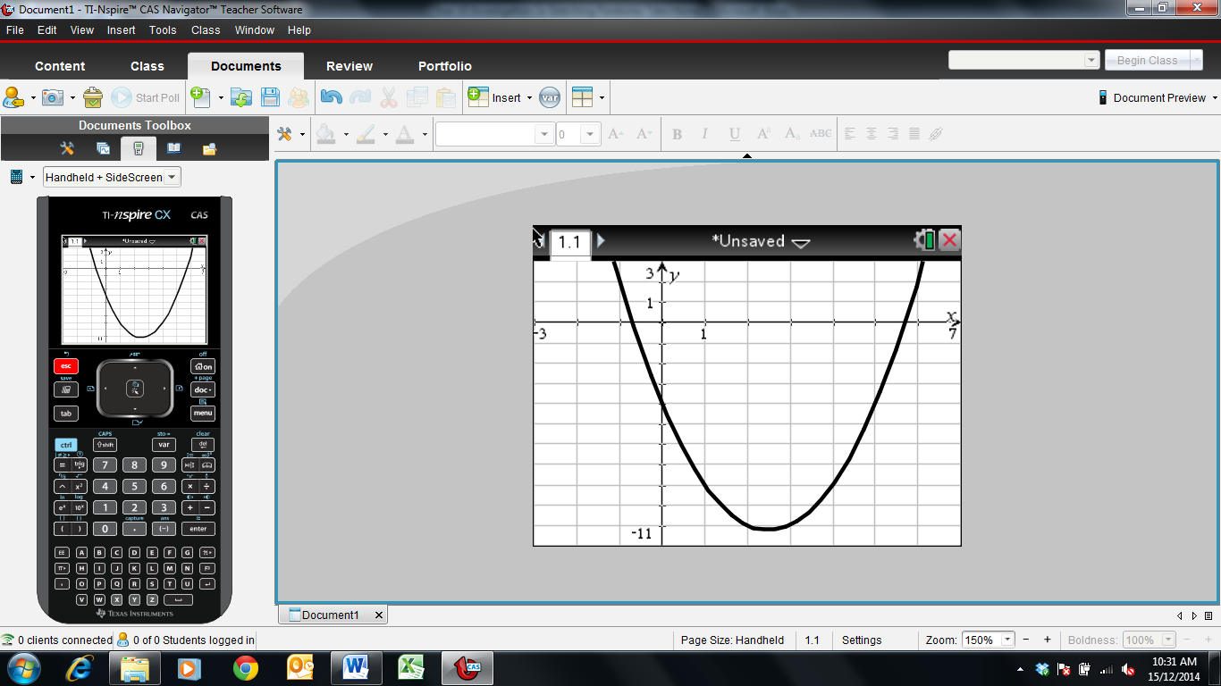
2
3
4
5
6
-1
-2
-4
-6
-7
-9
2
-1
-2
-3
-5
-8
-10

Key Features: y-intercept (0, -4), x-intercepts approximatly (-0.8, 0) and (5.8, 0), axis of symmetry x = 2.5, turning point (2.5, -10.25)

Exercise 3
Sketch the following parabolas and list their key features in the boxes on the right.
a) | $y=x^{2}+2x-5$  y-intercept =  x-intercepts = and  Axis of symmetry:  Turning Point =
b) | $y=x^{2}+8x+8$
c) | $y=x^{2}-5x+1$
d) | This graph is a little different  $y={-x}^{2}-4x+3$

End of Investigation

